4. Full-range leadership
- Background
Full range leadership model is a general leadership theory focusing on the behavior of leaders towards the workforce in different work situations. (Bass and Avolio, 1991) The full-range leadership model has been extensively exploring ever since 1980s. the model state three types of leadership style: laissez-faire, transactional and transformational leaderships. The model frame these three leadership style with degree of efficiency and degree of engagement, one concerned with how passive leader towards other and toward goals of organization, other concerned with the effect of certain leaderships styles on followers, group and organization (performance, internal motivation and wellbeing etc)

In details, full range of leadership model suggests 7 management styles on a continuum: laissez-faire, management by exception, contingent reward leadership, individualized consideration, intellectual stimulation, inspirational motivation, and idealized influence.

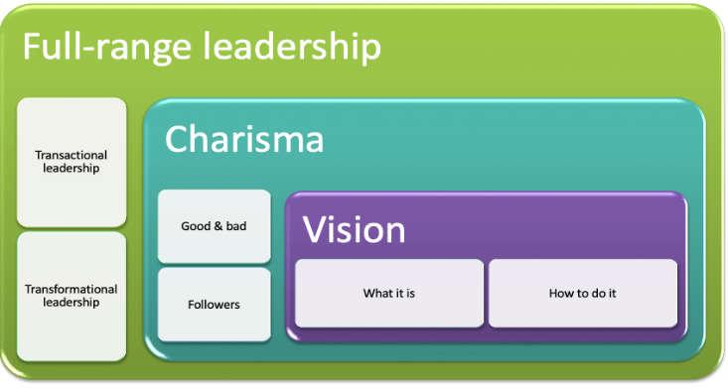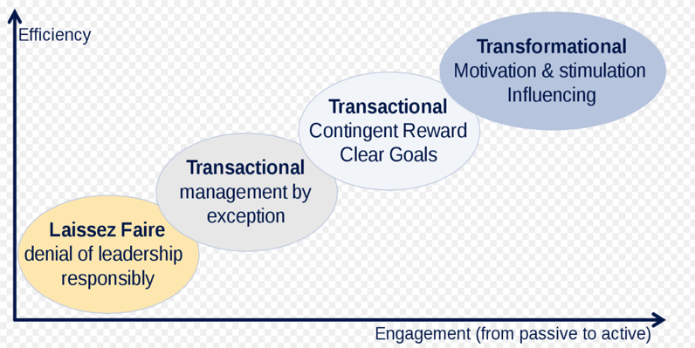

Laissez-faire Leadership
Laissez-faire Leadership is a leadership style with the absence of leadership.)
- As one of the lease effective and engaged leadership style
- It is characterized by an attitude avoiding any responsibility.
- Decision-making is left to the employees themselves, and no rules are fixed, delay of flowering up, and doesn’t emphasis on result
- There is no exchanged between leaders and others

- The main advantage of laissez-faire leadership is that allowing team members so much autonomy can lead to high job satisfaction and increased productivity.

- Many studies have found that this leadership style have led to team problems
- However, It can be damaging if team members do not manage their time well or do not have the knowledge, skills, or motivation to do their work effectively.

Transactional leadership
Transactional leadership refers to bulk of leadership that focus on the transaction (exchange#) between leader and followers.

- Transactional leadership is an integral part of the full range leadership model that focus on supervision, organisation, or performance.
- Transactional leaders promote compliance by followers through both rewards and punishments to keep followers motivated for the short-term.
- They also pay attention to followers' work in order to find faults and deviations.
.
- This type of leadership is effective in crisis and emergency situations, as well as for projects that need to be carried out in a specific way.

- Many high-level members of the military, CEOs of large international companies, and NFL coaches are known to be transactional leaders

- Transactional factors

- Contingent reward
- Exchange process between leader and followers which follower input effort for specific rewards
- Leaders try to obtain agreement on job and reward
- Management-by-expectation
- Involve collective criticism, negative feedback and negative reinforcement
- Active
Watch followers closely for mistake or rules violation and then take corrective action
Eg: sale supervisor
- Passive
Intervene only after the standard have not been met or problem arise
Eg: supervisor who give employee a negative feedback without actually talk with follower about why It is

Advantages:
- some of the advantages include it rewards individuals who are self-motivated and follow instructions.

- its benefits tend to be realized quickly when quickly achieving short-term goals.

- Since workers have clearly defined rewards and penalties, it could encourage productivity.

- It provides a clear and easy to understand structure.

- It is great for work environments where structure and systems need to be reproduced such as high-volume manufacturing.

Weaknesses
- it does not work well in flexible work environments.

- it does not reward individuals who take personal initiative.

- It can be viewed as limiting and not personal

- Creativity by employees is limited or non-existent.

Transformational leadership
Transformational leadership in full-range leadership model are one of the most efficient and engaged leaderships. This theory based on the attention of linking leadership and followership

Transformational leadership is a process that change and transform people. a process whereby a person engage with others and create connection thst raise the level of motivation and morality in both the leader and followers.

Transformational leadership styles focus on teambuilding, motivation, value, ethic and long-term goals, and to treat them at full human being. They also focus on and care about followers and their personal needs and development.

Transformational leaders set goals and incentives to push their subordinates to higher performance levels while providing opportunities for personal and professional growth for each employee.

Compared to transactional leaders, transformational leaders fit well in leading and working with complex work groups and organizations.

This theory has also related to charismatic leadership, which is leaders who have certain personality characteristic that give them a superman or exceptional power image.
.
Richard Ranson of the Virgin Group is a good example of a transformational leader. He pays attention to the concerns and needs of individual followers, changes followers’ awareness of issues by helping them look at old problems in new ways. However, some fascism leader like Adolf Hiltler also shown sign of transformational leadership in the negative side, by writing books to set the value and vision of a nation. However, these types of leader been consider as pseudotransformational leader.

- Model of transformational leadership
bass expend the theory focus more on the follower side, said that transformational leadership will apply on the situiotn that outcome are not positive and had combine the transactional and transformational together as a more effective leadership style

transformational process
- Raising followers level of consciousness about the importance and value of specific and idealized goals
- Getting followers to transcend theory own self-interest for the sake of of the team and organization
- Moving followers to address higher needs
- Require leaders to know their own behaviour related to the need of their followers MLQ questionnaire to let the leader know about their leaderships

- Transformational leadership factors

- Idealized influencer/charisma
- Leaders that are strong role models for their followers, and followers want to emulate the leaders
- High standard of moral and ethical, to do the right things
- Follower place a great deal of trust
- Provided followers vision and sense of mission
Example: Nelson Mandela

- Inspirational motivation
- Describe leaders who communicate high expectation to followers inspiring them thought motivation to commit to and part of the shared visions in the organization
- The use of symbol and emotional appeals to achieve more than followers self-interest
- Enhance team sprit

- Intellectual simulation
- Leadership that stimulated followers to be creative and to challenge their own belief and value as well as those of the leaders and organization
- Support followers to try new approach and develop innovative way of dealing with issues, think things out of box and creatively solve the problem. Eg: Designers
- Individualized consideration
- Leader who provide a supportive climate in which they listen carefully to the individual needs
- Coach and advisor and access followers to fully actualized
- Even help in their personal challenged
- Spend time and caring each employee in the unique way
- Strength
- Widely researched
- Consist with social popular notion of a leader
- A process of leaders and follower, not left entirely on the leaders’ responsibility
- Push the follower existing value, goals and interest to a higher level of standard

- Weakness
- Lack of conceptual clarity, wide range of activities and characteristics
- Overlap of with other leadership theories, like charismatic with transformational
- Transformational leadership theories treat leader as certain set of trait or personal disposition rather than behaviour that a person can learn and become, the trait theory are more problematic
- Give the image that leader is leading independently, and putting themselves above the follower’s need
- TL is responsible for changing follower value and goals, but who is going to determine the quality of the change ?

- The combine of transformational and transactional leadership are the most effective
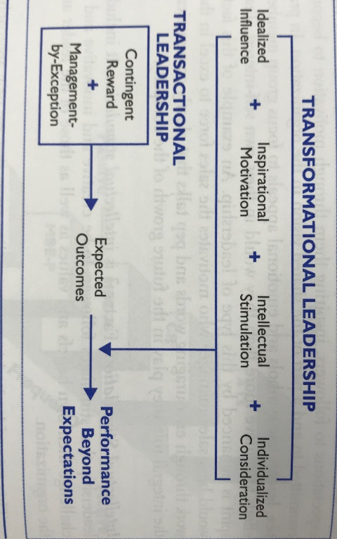

Base on this model, many studies have found transformational element argument the positive impact of transactional leadership, enhance effectiveness by enhance job satisfaction, acceptance of changes and performance.

.
Differences between transactional and transformational leadership
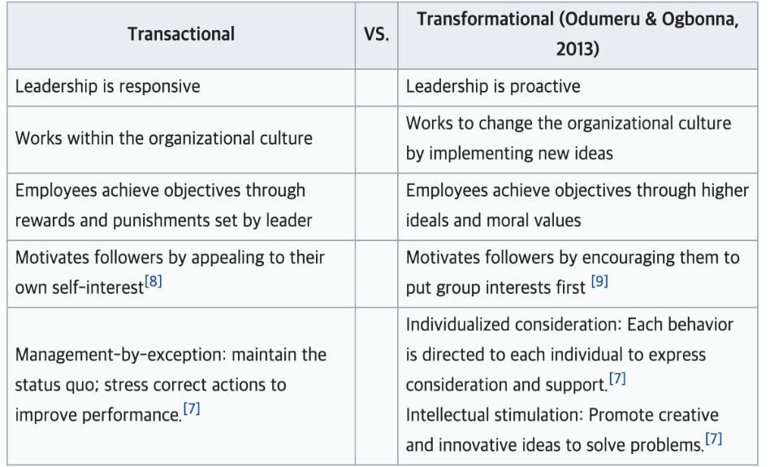
Transformational leaders look towards changing the future to inspire followers and accomplish goals, whereas transactional leaders seek to maintain the status quo.

Transactional leaders are willing to work within existing systems and negotiate to attain goals of the organization.

They tend to think inside the box when solving problems. On the other hand, transformational leaders are pragmatic and think outside the box when solving problems.

Transactional leadership is primarily passive. On the other hand, transformational leadership is interactive and inspiring.

The best leaders are transactional and transformational.

